**Java 1: Assignment #1**

Due: Tuesday, October 3, 2017

Please remember to read over the assignment rubric before answering these questions. Each question should be written in its own file for upload. When all questions are answered place the source code for each question in a folder, zip it up, then upload it to the assignment 1 upload area on the LMS. If there are any concerns let me know right away. Feel free to work with others to solve the questions but please code them on your own.

**Question 1**

Write a program that will randomly generate three integers and asks the user what the summation of the numbers is. If the answer is correct the program will display true, otherwise the program will display false.

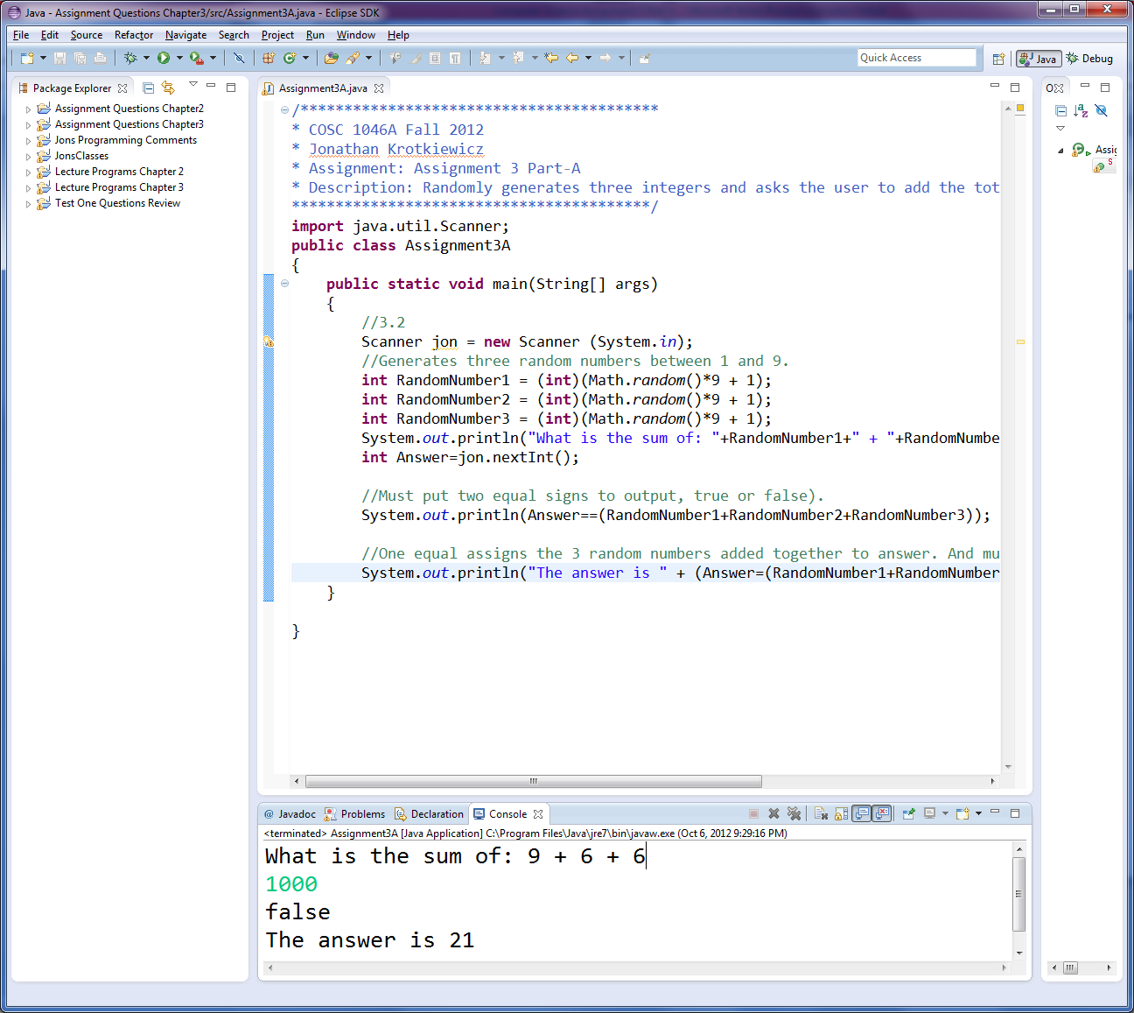Here is an example of the program output:

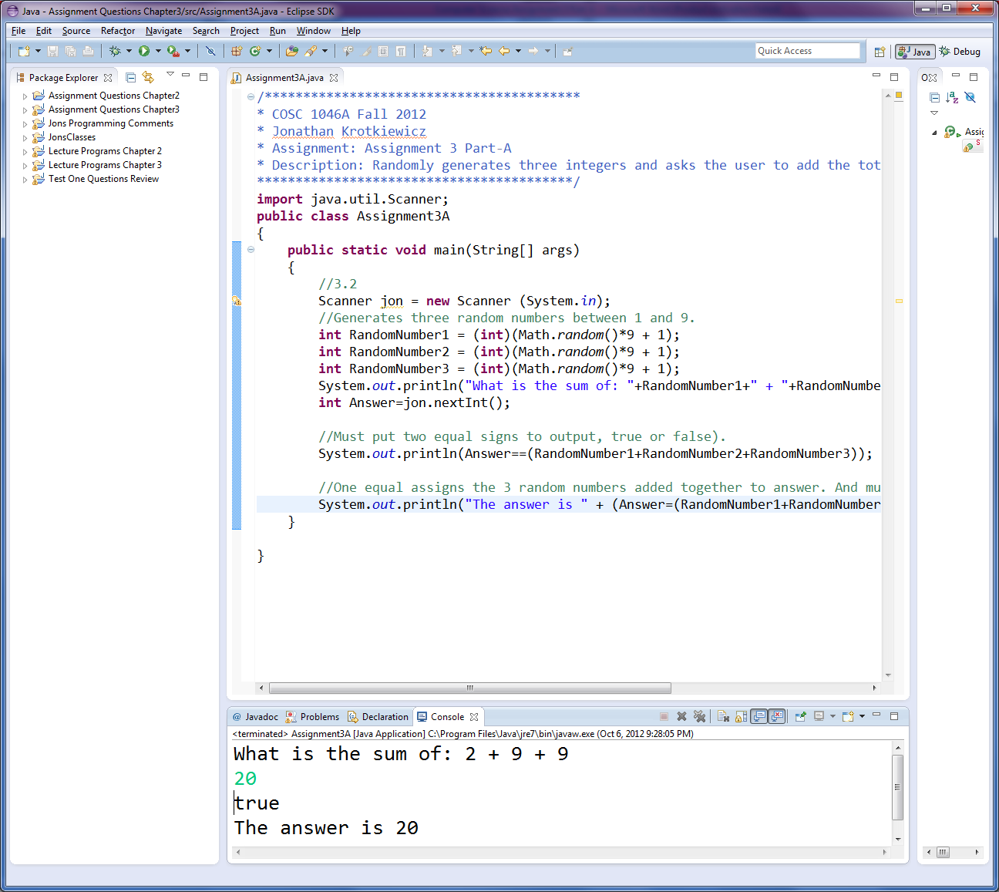

**Question 2**

Write a program that will generate 50 random integers in the range -500 and 500 and performs the following functions:

1. Count the number of negative numbers.
2. Count the number of positive numbers.
3. Calculate the average value of the negative numbers.
4. Calculate the average value of the positive numbers.
5. Determine the largest number.
6. Determine the smallest number.
7. Calculate the average of the sum of all the numbers.

Here is an example of the program output:

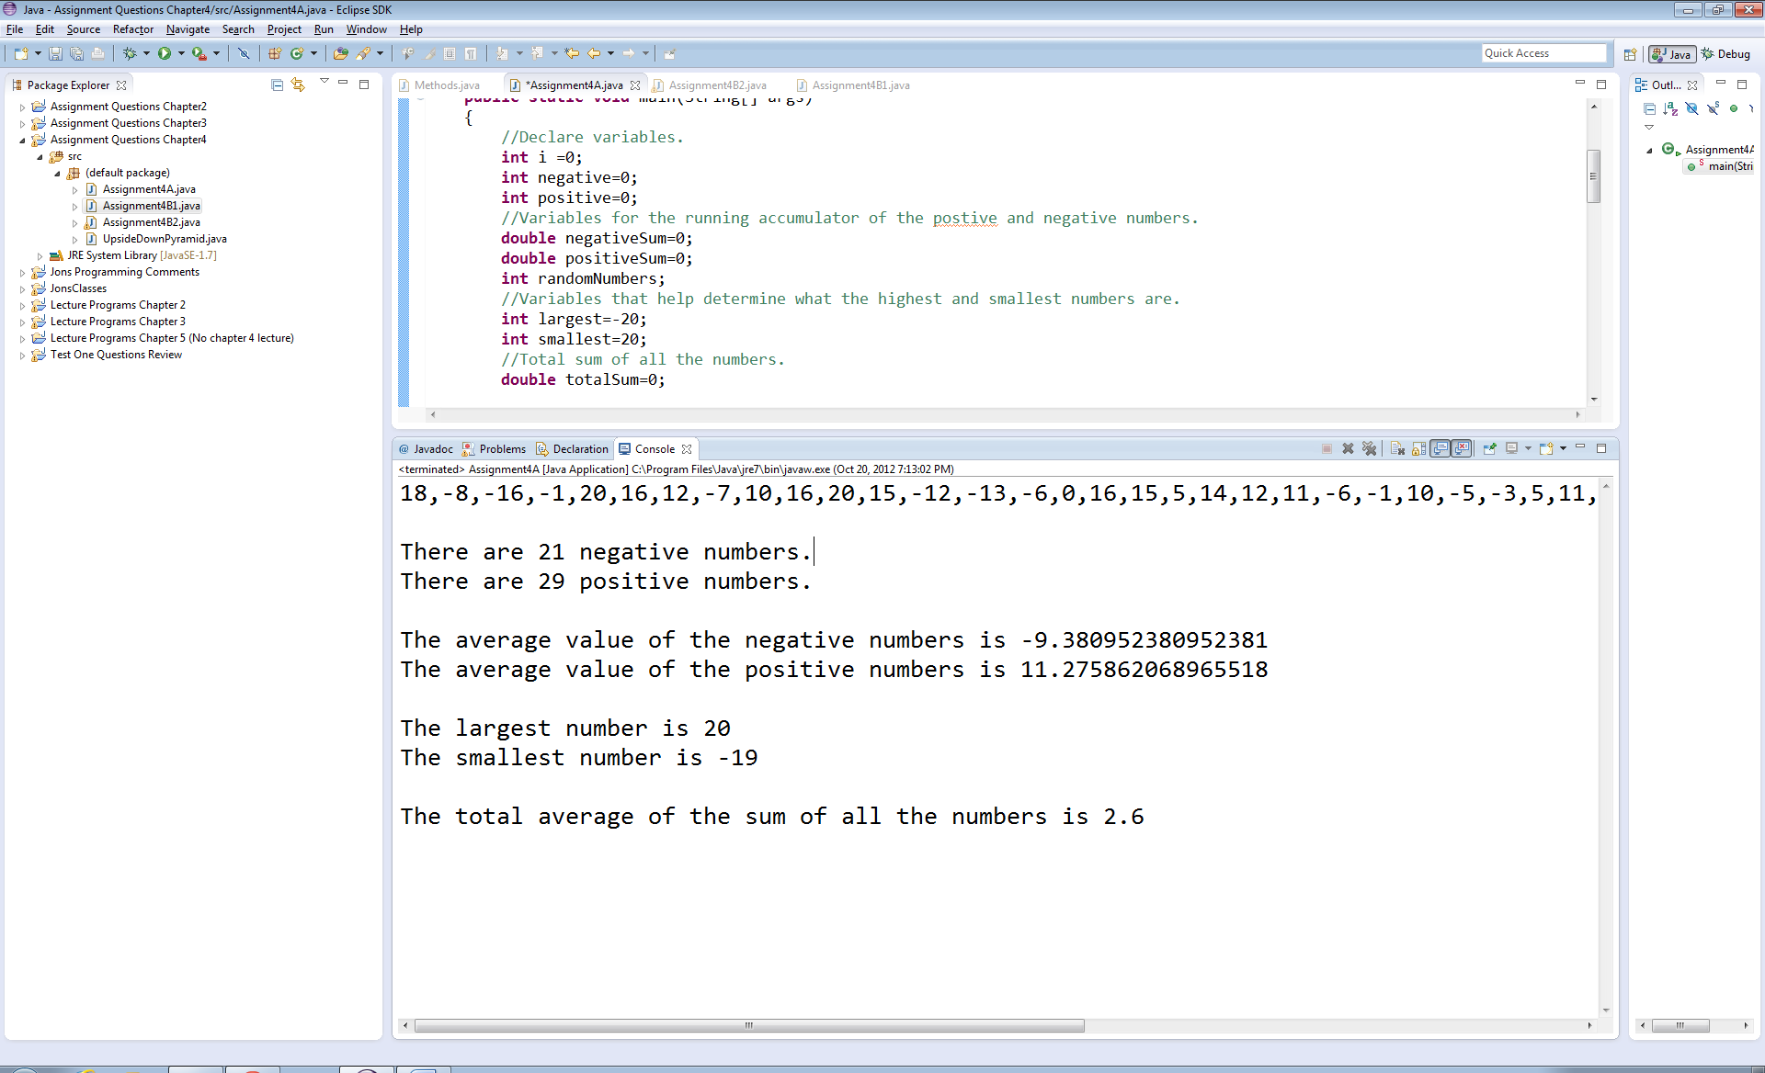

**Question 3**

Write a program that will display the hex value associated with a given decimal value in the range 1 – 15 using a switch statement. The user should be able to enter this value. If the value is outside of the range 1 – 15, an error message should be displayed to the user and they should be able to try again with another number.

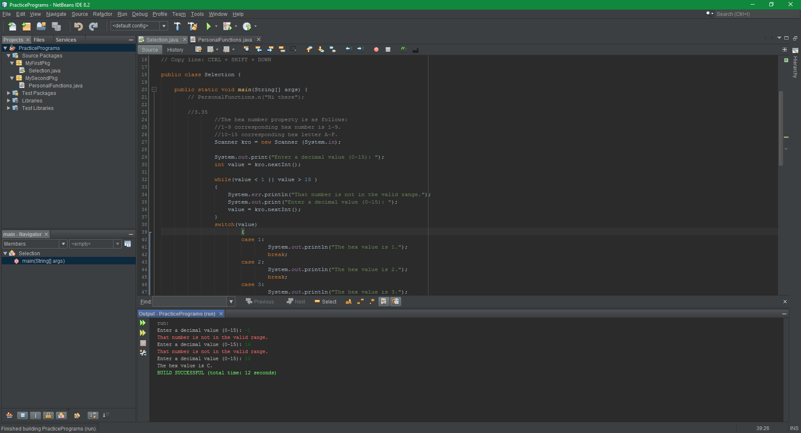Here is an example of the program output:

**Question 4**

Write a program that will display the following pattern using loops. **Hint:** This can be accomplished with 2 for loops, and no if statements. Try to think of the sequence of iterations to accomplish displaying this pattern.

Here is an example of the program output:

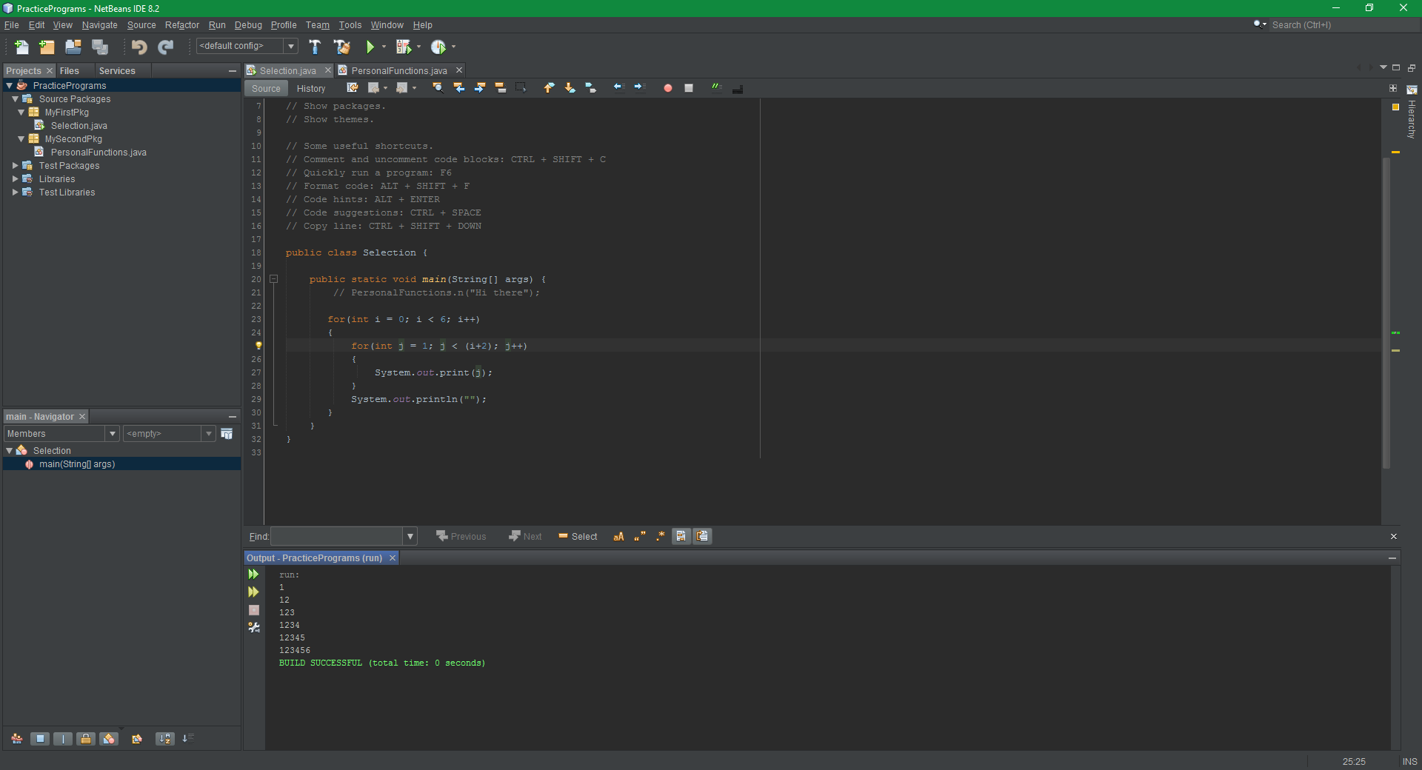

**Question 5**

Write a program that will perform the following functions. If the user does not enter anything and simply presses enter or just enters a series of spaces, the program should display this problem to the user.

1. Allow a user to enter a string.
2. Print out the number of characters in the string.
3. Print out the first character of the string.
4. Print out the last character of the string.
5. Print out the reversed of the string to the user.
6. Print out the decimal value of each character of the string.
7. Convert the string to the upper case representation.
8. Convert the string to the lower case representation.

Here is an example of the program output:

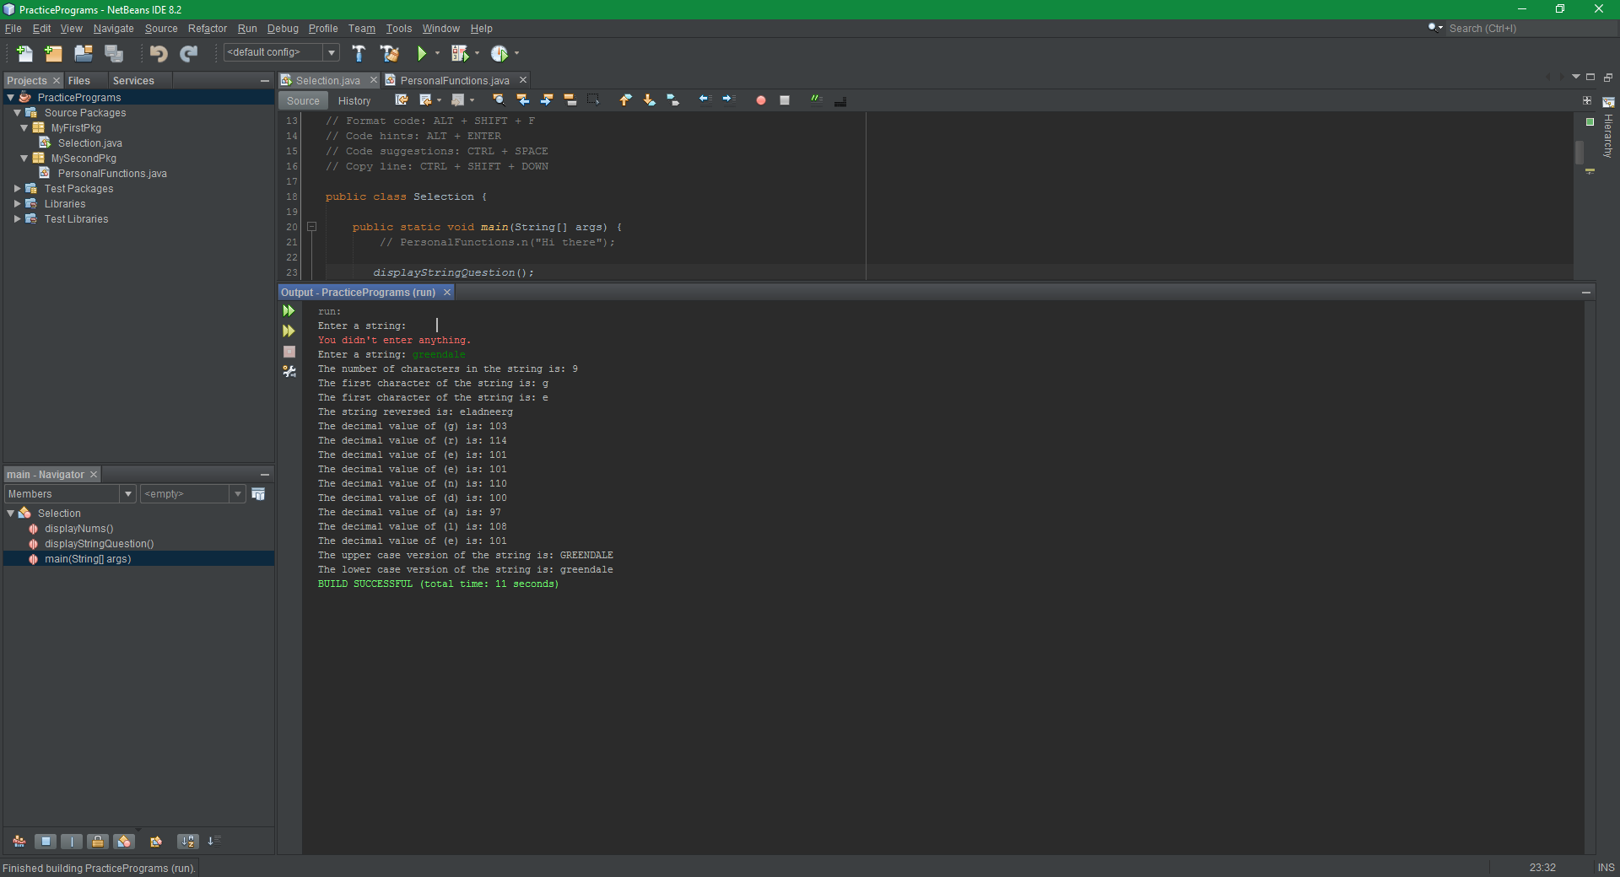

**Question 6**

Write a program that will randomly select between these three words: (“green”, “johncena”, “java”). Once the choice is made display to the user a series of underscores matching the number of characters in the word. If the word is “greendale” then “_ _ _ _ _ _ _ _ _” will be displayed.

The user is then able to guess what the word is. Any guess the user makes should be converted to lower case (remember every string has this function built in). If the user guesses a word longer than or less than the selected word’s length let them know the guess is too long or short. If the word guessed is the correct length let the user know if the letter guesses should be greater or less then, or if they are correct. Lastly, the program should display how many times it took the user to guess the correct word.

Here is an example of the program output:

